New Digital Library Perspectives from International Library and Information Point of View: The Case of Global Memory Net

Ching-chih Chen
Professor
Graduate School of Library and Information Science
Simmons College, Boston, MA 02115
E-mail: chen@simmons.edu

Abstract: With the exciting convergence of content, technology, and global collaboration in this digital era, there are unprecedented potentials as well as challenges for developing digital libraries of all kinds. In the case of Global Memory Net (www.memorynet.org), its newly developed Interactive Multimedia Content Retrieval System (tentatively called i-M-C-S) has managed to incorporate many innovative concepts and functions to meet the challenges of a world digital library and gateway. This paper will articulate these challenges, including those selected ones as listed: (1) Using the Web as a platform to integrate seamlessly all types of multimedia resources. (2) Digital images can not only be retrieved in traditional ways by metadata fields, but also by cutting-edge content-based retrieval methods (CBIR). (3) Once the desired image(s) is(are) located, associated sound, digital video, textual annotation, as well as expanded bibliographical and Web resources can be obtained by the simple clicks of the mouse. (4) Available resources can be retrieved by searching a single collection, or by cross-collection (or multi-collection) search. (5) Multilingual presentation as well as retrieval should be possible. (6) Geographical retrieval should be provided. (7) While universal access is the goal, the users should be possible to contribute their resources as well. In addressing these challenges, it should become clear the importance of international collaboration for content and technology development.

INTRODUCTION

Since 1993, I have advocated the concept of a world digital library. My first paper on this subject was delivered at the National Central Library at the occasion of its 60th Anniversary Celebration [Chen, 1993]. But, in those early days, the concept was started mostly from the “technological” point of view, contemplating the possibilities of linking the world digital collections together with the availability of high-speed network like the Internet as we commonly knew that a couple of years later. In the early beginning, there was little idea regarding how to deal with the digital collections. As time goes on, such a concept has moved rather rapidly to include many other components. Content has been considered to be just as important, if not more, as technology. In other words, with all the rich information resources in the world, if they are not digitally available, they will not be able to be accessed, retrieved, shared and enriched on the Web. Research activities related to content have proliferated in the areas of digital collection creation and development, organization and standards, interoperability and scalability, and many others. One important fact in relation to content is also becoming clear – no institution can provide everything, thus global collaboration in digital collection development becomes essential. In addition, it is natural to ask what are these digital resources are developed for. The component of users and uses has surfaced as another important part of the digital library research.

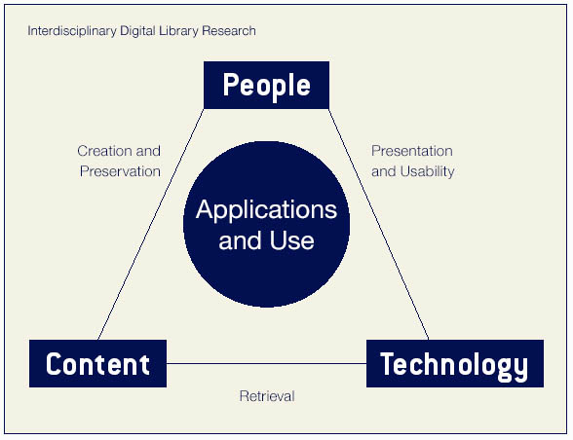
The above macro introductory description, though over-simplified, is sufficient to provide a sketchy conceptual model, which coincides well with an interdisciplinary digital library research model, collectively developed by the members of the DELOS-NSF Working Group in Digital Imagery for Significant Cultural and Historical Materials [Chen, 2005]. This model was presented at LIDA 2004 at the keynote speech [Chen, 2004] – Figure 1. This illustration shows clearly the triangular relationships among people, content, and tech-
Figure 1. Conceptual Model of an Interdisciplinary Digital Library. nology. In other words, an inter-
disciplinary digital library needs to develop technologies to enhance the way all kind of users can use, share and contribute to the world digital content.

CHALLENGES FOR DEVELOPING A WORLD DIGITAL LIBRARY

Conceptual model as described above is essential for developing a digital library because it provides a map to guide us in our planning and developing processes. Yet, when actually creating a digital library application, one will face with many difficult tasks due to the need to get down to the granularity of creating and developing the building blocks. Like completing a puzzle, all small and large pieces have to fit well together to create the complete whole.

In the case of Global Memory Net, since it is intended to be a world digital image library and gateway, we have conceptually set various requirements as our challenges for developing such a world digital library. The following are some of the selected ones:

- Instead of using web for publishing, we need to use web as a platform to enable more user participation,
- We need to provide seamlessly integrated multimedia information services in order to enrich user experience,
- Our system needs to provide innovative information services, and it is not to offer packaged software for building databases,
- User’s need and behavior in information seeking should not be pre-determined, thus the search and retrieval capabilities have to be able to accommodate all kinds of needs,
- User needs to control the use of data, thus he/she can choose to search one single collection or multi-collections,
- What we offer should be a knowledge base and not database(s), therefore once simple information is found, user can and should be enriched with more related multimedia information, and mixable or re-mixable resources if desired,
- We need to provide freely accessible and searchable web resources, and not just links with them,
- To enhance user experience and ability to consume the obtained information, multilingual capabilities are essential for both presentation as well as retrieval,
- User should be able to lead from one tiny useful information to play big and link that to the world collections as well as world bibliographic and web resources,
- User should be able to address the content in any granularity,
- Geographical access to content should be provided,
- Intellectual property of the content provider should be protected,
- User should be able to use the discovered and retrieved data to develop his/her own project(s),
- User should be able to actively contribute to the library,
- Etc.

THE CASE OF GLOBAL MEMORY NET

Global Memory Net (GMNet) was started in 2002 with expanded scope from the Chinese Memory Net which was started in 2000 with support from the International Digital Library Program of the National Science Foundation. During the period of 2000-2003, there was a macro conceptual model with considerably smaller number of novice functionalities. Although Chinese Memory Net was intended to be a global collaborative project, but the progress was slow. Global Memory Net opened the door to more possibilities and potential partners. Particularly, in the Fall of 2005, with the National Science Foundation supported community building effort, 7 visiting researchers from China, Croatia, and Vietnam joined the GMNet research team full-time for 3 to 5 months each. The project really took off with this global collaboration. We were able to develop both content and technology by fully leveraging the expertise of each visiting researcher. All seven came with their own valuable local content resources, and three, in particular, were able to contribute substantially to the system development [Zhang and Chen, 2005; Badurina and Chen, 2006].

From the content side, the GMNet in-house collection has been enriched with the invaluable and unique resources of the following:

- Vietnam National Ethnological Museum (VME) – the 54 ethnic minority groups of Vietnam,
- Hainan University’s Li minority ethnic culture,
- Shanghai Jiaotong University’s Chinese musical database,
- University J. J. Strossmayer, Osijek, Croatia - Selective collections of the Museum of Slovenia of Croatia
- Xian Jiaotong University - The Xian related artifacts
- Sichuan University - The Chengdu related artifacts

Our visiting researchers brought with them resources of the above subject, learn the process of creating digital collections, prepare needed metadata, and implement necessary tasks needed for content building of the specific collection(s) for GMNet, and most importantly, learn how to collaborate in building a powerful knowledge base.

From the technology side, we have developed our own in-house Linus/MySQL/PHP-based interactive Multimedia Content retrieval System (i-M-C-S) with much added functionalities from Version 1.0 to the current Version 4.5 since 2004. The later versions have been developed based on the basic system structure of Version 2.0 with functions as shown in Figure 2 [Zhang and Chen, 2005]. Version 2.0 was mainly developed by S. Q. Zhang of Sichuan University under Chen’s supervision. The only exception of our in-house development relates to the content-based image retrieval (CBIR) capabilities, for which we collaborate with James Z. Wang of Penn State University by using his SIMPLIcity, developed when he was at Stanford University.
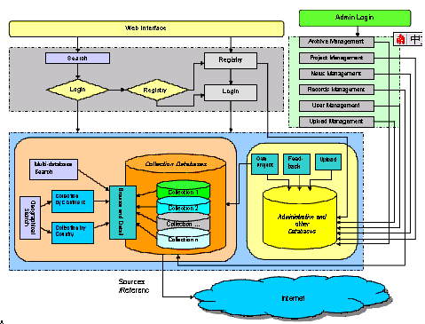

Figure 2. Functionality Scheme of Global Memory Net [Zhang and Chen, 2005].
Under the overall supervision and guidance, Version 3.0 was enhanced collaboratively by the visiting researchers from Sichuan University (S.Q. Zhang), Xian Jiaotong University (Xiaobo Xiao), and University J. J. Strossmayer, Osijek, Croatia (Boris Badurina), while Versions 4 to 4.5 are mostly the work of Badurina with early assistance from Xiao. Clearly, these are perfect examples of productive international collaboration to capitalize new opportunities of the digital age, and to learn to provide innovative information services with new kind of knowledge base.

Features of Global Memory Net

In the last two years, we have addressed the challenges outlined above, and have developed our system, i-M-C-S, with many features and functionalities in line with our initial requirements. Although these would be best to be experienced with the real-time presentation and discussion, the following summary with some of the selected feature is provided for the benefit of the readers:

- Web is used as a platform, and not as a publishing medium.
- Instant access to rich image collections – One can access to over 30 image collections in GMNet with over 20,000 images as well as over 2400 digital collections from over 80 countries. Although GMNet’s own current collections have focused in culture, history, and heritage, the World Digital Collection in GMNet has included over 2400 digital collections cover all subject areas. This includes over 100 collections from UNESCO’s Memory of the World, over 290 collections from the US Library of Congress, as well as those from other major national libraries, archives, museums, academic institutions, etc. In other words, the world’s rich resources are instantly accessible at a simple click of the mouse. Figure 3 shows how these collections can be accessed by selecting the collection from the left blue panel of “Collections”.
- Easy and flexible traditional search – Select a collection of interest, and use traditional search by metadata fields when one knows the precise information to search in this collection.
- User can explore the unknown collection and learn its coverage – For an unknown collection of curiosity to the user, one can browse the collection, but more significantly, the “random” feature permits one to explore and learn the coverage of this collection. In seconds, one can learn how to retrieve effectively by the variety of images displayed as well as the words showing up for the titles as suggestive keywords. Figure 4 shows the great diversity of images covered in the UNESCO’s Memory of the World collections. A quick glance of this screen, one can have a good idea on the subjects involved.

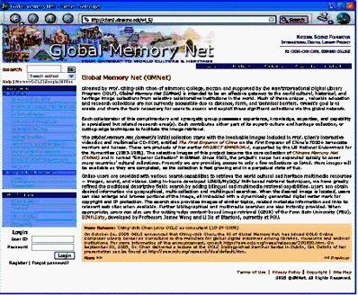

Figure 3. Home Page of Global Memory Net with Collections Panel on the Left.

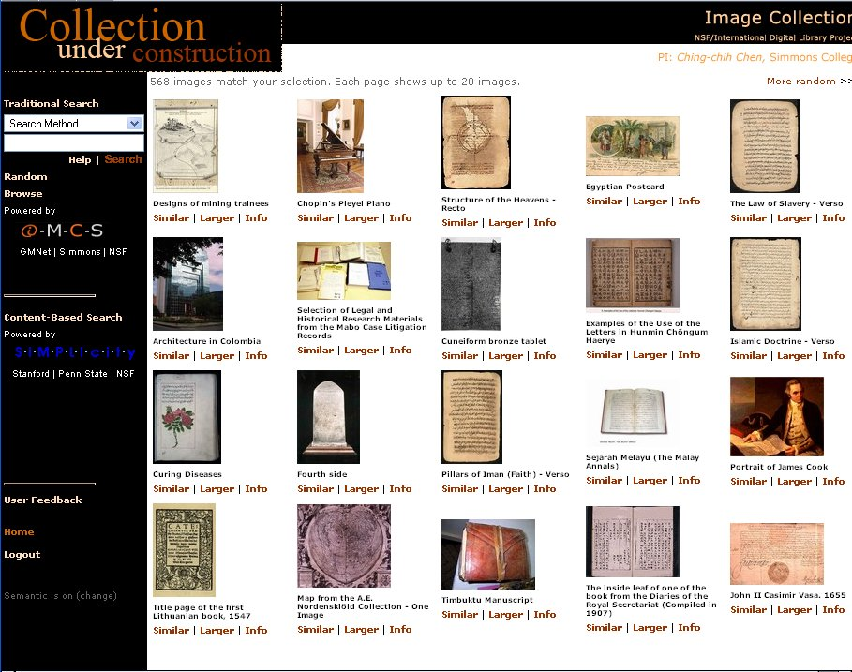

Figure 4. “Random” of UNESCO’s World Memory instantly display a great diversity of topics covered


- Instant retrieval of similar images of interest by using cutting-edge retrieval techniques – Once a picture of interest is spotted, one is given three choices:
1) to find pictures of the same color or shape using the cutting-edge content-based image retrieval (CBIR)**,
2) to zoom the image for larger sizes and more details, or
3) to have some descriptive information, as shown in Figure 5 on the right.
**Our CBIR uses SIMPLIcity of Prof. James Z.
Wang of Penn State University.
Figure 5. Chosen image
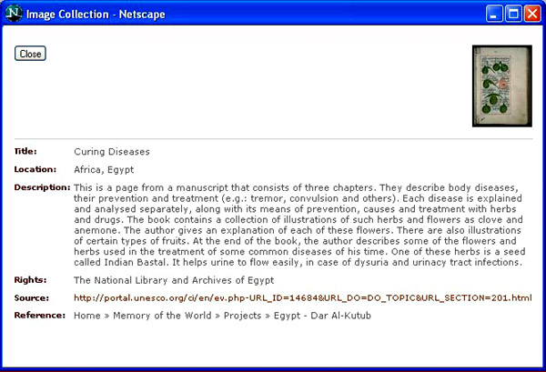
  - “Info” – Want to know more about this image? “Info” will yield instant descriptive information about it, as shown in Figure 6. This information can be in multilingual forms. In addition, a simple click on the source, the user will be ready to browse and search information on the actual Web site.

Figure 6. Descriptive information
(metadata) of the image are
Available in both English and
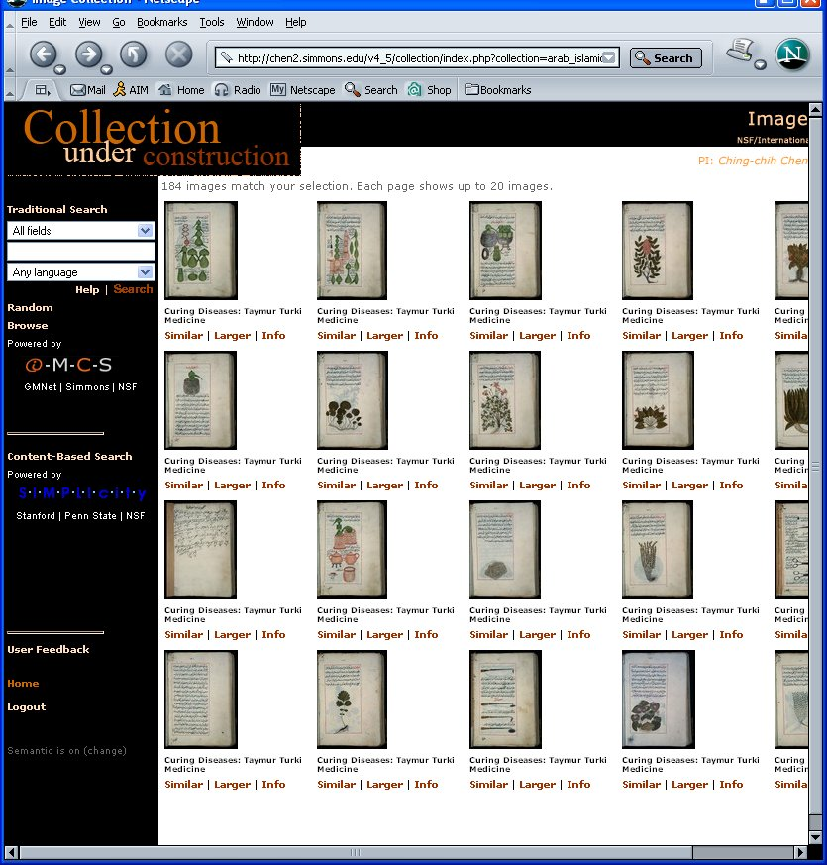
French of this Islamic image

  - “Similar” – Curious about what other similar images of same color and Shape? Figure 7 shows that a simple click will display all the similar images on the screen for further browse…
Undoubtedly this opens up a new horizon to the user!

Figure 7. Instant display of all the
similar images of similar color and
shape.

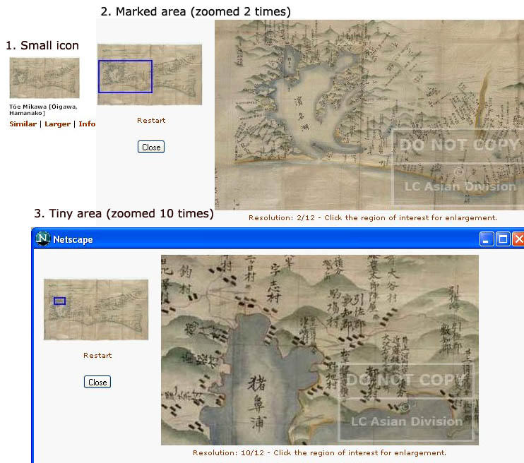
“Larger” – By clicking this, instant magnification of a chosen image in defined areas is shown. Depending on the resolution of the image, some images can be zoomed over a dozen of time. Note the rare Japanese Inoh Map icon of the Library of Congress’ Asian Division (Figure 8) has no meaning at all. Yet, this tiny icon-image can be magnified to 12 times with much significant information to the scholars.

Figure 8. This figure shows the multiple levels of magnification.

Note also the dynamically generated digital watermark.

Dynamically generated digital watermark for copyright protection of the content provider – See Figure 8 above.

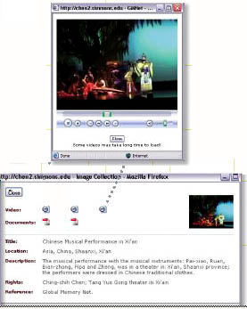
Seamless integration of multimedia information – If relevant resource information on a chosen image is available in formats other than textual annotation, the user can then retrieve the relevant audio, video, etc… by a single click of the mouse, as shown in Figure 9.

Figure 9. The “Info” screen shows the availability of 3

digital videos and 2 PDF document files for instant retrieval. Some also include sound and other files.

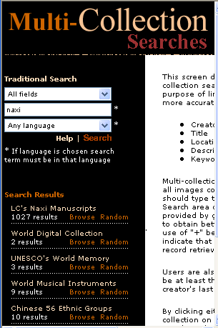
User can choose to conduct single collection or multi-collection search – For example, if one wants to find information on Naxi, one of the 56 minoriy ethnic groups in China, one can choose to search Library of Congress’ Naxi Manuscript Collection, or one can do multi-collection search, and the search results will instantly be shown (see Figure 10). Thus, in addition to 1027 images found in LC’Naxi Manuscripts, one can also see additional resources and images in other collections.

User can have much more in-depth learning of the subject by using expanded bibliographical and web resources – For example, one can instantly find relevant books from the half-billion bibliographical records of OCLC/World Cat, or web resources like Google, Wikipedia, Internet Archive, Million Books etc…

Multilingual display of descriptive information as well as multilingual retrieval – Currently GMNet already has

contents in English, Chinese, Croatian,

Figure 10. Multi-collection retrieval results

French, Italian, Japanese, Spanish, Thai, Vietnamese, etc.

User can conduct geographical searches by continent and country – Information on over 230 countries can be searched.

In addition to these features, it is worthy to stress that GMNet positions its user to:

Participate actively during his/her own information seeking process,

Decide how he/she would like to use the obtained information,

Develop his/her own project by remixing the retrieved images, and

Be an active content contributor to GMNet.

CONCLUSION

As mentioned earlier, Chinese Memory Net started in 2000 with the support from the National Science Foundation’s International Digital Library program. Since 2002, Chinese Memory Net has expanded to Global Memory Net. The conceptual model of this world digital image library was conceived as early as 1993, and further refined in the late 1990s. The current GMNet’s R&D activities started in 2002.
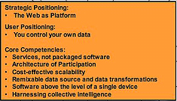

For the meantime, as the Web use has proliferated to an unprecedented scale, the concept of "Web 2.0" began to surface. It started at a conference brainstorming session between O'Reilly and MediaLive International in 2004, and “in the year and a half since, the term "Web 2.0" has clearly taken hold, with more than 9.5 million citations in Google.” [O’Reilly, 2005].

Figure 11. Part of the O’Reilly “meme” map showing the Web 2.0 Core

Although there are still a lot of disagreements on what Web 2.0 is all about and for, surprisingly we actually find considerable agreement between the core concepts of GMNet and the Web 2.0 core as shown in Figure 11, and some of the ideas that radiate out from this core.

It is clear to us that the keywords for next-generation web-based application, including digital libraries, should be “user,” “services,” “participation,” “knowledge base” etc., and NOT “publishing,” “packaged software,” and “database(s)”. Yet, for digital libraries, how can we provide innovative information services for full and active user participation without contents and cutting-edge technologies? If Global Memory Net is an example in addressing this question, then it has pointed the way to collaboration among all types of information providers and not just among libraries, and at all levels from local to regional, regional to country, and country to the world. It has big organizations like UNESCO, Library of Congress, national museums, as well as small organizations and individuals, as its content collaborators. Technologically, it collaborates with experience computer science specialists as well as knowledgeable system developers. There is a role for everyone!

Technology has developed so fast that it has provided us amazingly opportunities in this exciting digital age. We are indeed living in an interesting and exciting time! Let’s make the best of it!

ACKNOWLEDGMENT

Global Memory Net is supported by the National Science Foundation’s International Digital Library Program under the Grant Nos NSF/CISE/IIS-9905833 and NSF/CISE/IIS-0333036.

REFERENCES

[Badurina and Chen, 2006]. Badurina, Boris and Ching-chih Chen, “Osijek Treasures Are One Click Away at the Global Memory Net,” Paper to be presented at LIDA (Library in the Digital Age) 2006, Dubrovnik, Croatia, May 30-June 2, 2006.

[Chen, 1993]. Chen, Ching-chih, "Technological Potentials for the Global Digital Library," In: Proceedings of the International Conference on National Libraries - Towards the 21st Century, Taipei, Taiwan, April 20-24, 1993. Taipei, Taiwan: National Central Library. pp. 859-868.

[Chen, 2004]. Chen, Ching-chih, "The Promise of International Digital Library Collaboration for Innovative Use of Invaluable Resources," In: Human Information Behaviour & Competences for Digital Libraries. [Proceedings of the Libraries in the Digital Age, Dubrovnik and Mljet Island, Croatia, May 25-29, 2004.] Osijek, Croatia: University J. J. Strossmayer in Osijek. pp. 7-15.

[Chen et al, 2005]. Chen, Ching-chih, Howard Wactlar, James Z. Wang and Kevin Kiernan, "Digital Imagery for Significant Cultural and Historical Materials - An Emerging Research Field Bridging People, Culture, and Technologies," International Journal on Digital Libraries, 5: 275-285 (2005).

[O'Reilly, 2005] O'Reilly, Tom, What Is Web 2.0: Design Patterns and Business Models for the Next Generation of Software, September 30, 2005.
http://www.oreillynet.com/pub/a/oreilly/tim/news/2005/09/30/what-is-web-20.html

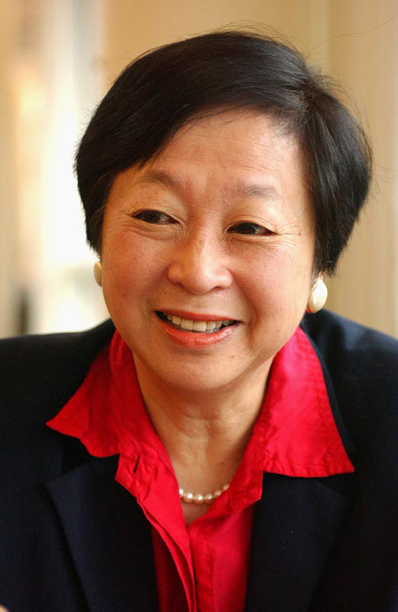
Ching-Chih Chen is Professor of the Graduate School of Library and Information Science, Simmons College, Boston, and is a consultant and speaker to over 40 countries. She is the author/editor of more than 35 books and over 200 journal articles in areas of new information technologies, such as global digital libraries, multimedia technology, digital imaging, interactive videodisc technology, global information infrastructure, information management, and information resources, etc. She produced the award winning interactive videodisc and multimedia CD entitled The First Emperor of China, supported by the US National Endowment for Humanities (NEH). Currently she is leading two major NSF/International Digital Library Projects (IDLP): (1) Global Memory Net, a gateway to the world cultural, historical, and heritage multimedia resources, with collaborators from different part of the world, and (2) International Collaboration to Advance User-oriented Technologies for Managing and Distributing Images in Digital Libraries. She is also co-PI, with Prof. Raj Reddy of Carnegie Mellon University, of the China-US Million Book Digital Library Project. Photo credit: Justin Knight6
A Fellow of the American Association for the Advancement of Science, she was appointed by President Clinton in February 1997 to serve as a member of the U.S. President's Information Technology Advisory Committee (PITAC). PITAC was established by a new Presidential Executive Order. Under both Presidents Clinton and Bush during 1997 to December 2002, she co-chaired the PITAC Subcommittee on International Issues, and was a member of the PITAC Subcommittees on Next Generation Internet (NGI) and IT*2 Initiative Review; and Panels on Digital Divide, Digital Library, Learning of the Future, and Individual Security. She also chaired the PITAC's activity on Digital Divide for Smaller Institutions. During 1987 to 2001, Dr. Chen was Chief Organizer of a series of 12 International Conferences on New Information Technology (NIT) in many continents of the world. The outcome of NIT '99 (Taipei) and NIT'2001 (Beijing) are the two-volume books related to the development of Global Digital Libraries – IT and Global Digital Library Development (1999) and Global Digital Library Development in the New Millennium: Fertile Ground for Distributed Cross-Disciplinary Collaboration (2001). She is a recipient of many major awards, and was also elected in 1985 as Fellow of the American Association for the Advancement of Science. She served as an Honorary Professor of Tsinghua University in Beijing from August 1999 to 2002 and University of Hainan, China since 2004. Active in the digital library area she was the co-Chair of the 4th ACM/IEEE Joint Conference on Digital Libraries (JCDL) of 2004 held in Tucson, Arizona in June 2004. She was on the Advisory Board of DELOS (the European Digital Network for Excellence), serving as the US Co-Chair of the NSF/DELOS Working Group in Digital Imagery for Significant Cultural, Historical and Heritage Materials, and served as the co-editor for the Journal of Digital Library’s Special Issue on Multimedia Contents in Digital Libraries (February 2006). A sought-after international speaker, in the last two years alone, she delivered keynote speeches and made presentations at many international conferences including those in Delhi and Bangalore, India; Dubrovnik, Croatia; Buenos Aires, Argentina; Beijing, Shanghai and Hangzhou, China; Kawasaki, Japan; Tainan, Taiwan, etc. She is on the advisory board of the major China Digital Library Project of the National Library of China; in October 2005, she was appointed as a consultant to OCLC for its Global Digital Initiative (http://www.oclc.org/news/releases/200520.htm); and receivedthe coveted LITA/OCLC Kilgour Award from the Library Information Technology Asso-ciation in June 2006 (http://www.ala.org/ala/pressreleases2006/april2006/2006KilgourAward.htm).

To be delivered as an opening keynote speech at the International Conference on Developing New Mode of Library Cooperation (掌握知識，創造先機---展開創新的圖書館合作模式研討會), Tainan, Taiwan, May 18-20, 2006.

